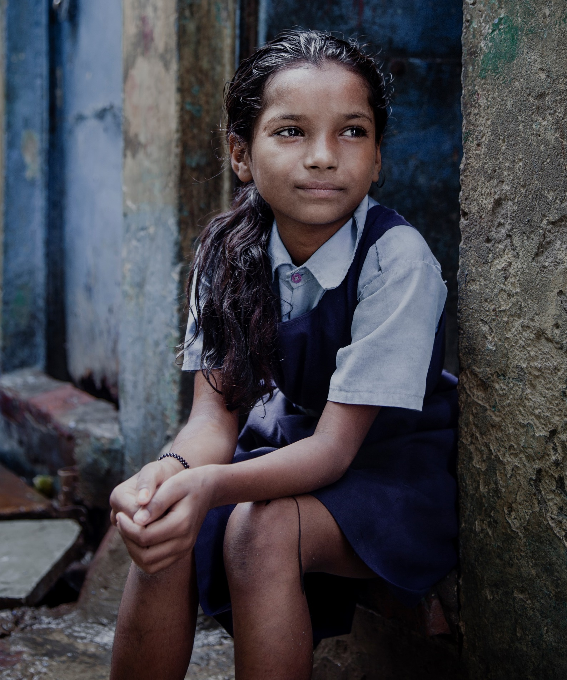

Request for Proposal
Online version of A guideline and toolkiT on
COMMUNITY LED CHILD PROTECTION

Introduction

1.1 Overview of Save the Children
Save the Children is the world's leading independent organisation for children, comprised of 29 international member organisations operating in over 68 countries. Save the Children UK (SCUK) is one of the member organisations.
We save children’s lives. We fight for their rights. We help them fulfil their potential.

Our vision
Our vision is a world in which every child attains the right to survival, protection, development and participation.

Our mission
Our mission is to inspire breakthroughs in the way the world treats children, and to achieve immediate and lasting change in their lives.

Our values
- Accountability
We take personal responsibility for using our resources efficiently, achieving measurable results, and being accountable to supporters, partners and, most of all, children.
- Ambition
We are demanding of ourselves and our colleagues, set high goals and are committed to improving the quality of everything we do for children.
- Collaboration
We respect and value each other, thrive on our diversity, and work with partners to leverage our global strength in making a difference for children.
- Creativity
We are open to new ideas, embrace change, and take disciplined risks to develop sustainable solutions for and with children.
- Integrity
We aspire to live to the highest standards of personal honesty and behaviour; we never compromise our reputation and always act in the best interests of children.

We are committed to ensuring our resources are used as efficiently as possible, in order that we can focus them on achieving maximum impact for children.

1.2 Scope of Contract Opportunity
Save the Children seeks a consultant(s) who specialises in communications, editing, content development for electronic or mobile platforms, and web development to develop a user-friendly online version of an existing guide and toolkit which aims to strengthen community-based child protection practice. The consultant(s) will also have a background in development issues and/or child rights and protection.
The version produced will be widely available for use by development practitioners and others around the world.
The aim is to launch the user-friendly guide in the first half of November 2018.

More information on Save the Children’s requirements can be found in Section 3 of this document.

2. Instructions for bidding

2.1 Timescales
Bidders are requested to respond to sections 4-6 then return this document with the relevant sections completed via email (no hard copies required) to Judy Roberts, Acting Deputy Head of Child Protection, Save the Children UK, at j.roberts@savethechildren.org.uk

Deadline for submission: 3 July 2018
This Request for Proposal does not constitute an offer and Save the Children UK (SCUK) does not bind itself to accept any proposal. SCUK reserves the right to accept a proposal in part, rather than in full.

2.2 Evaluation
Evaluation of the proposals will be based on the following criteria in order to determine the best agency for SCUK:
- Experience and Expertise
- Team – demonstrating the right level of experience and fit for the assignment
- Proposed methodology
- Commercial proposition – acknowledging that SCUK is a charity and that the proposal represents value delivery

2.3 SCUK not bound
This Request for Proposal does not constitute an offer and Save the Children UK (SCUK) does not bind itself to accept the lowest price, or any, proposal. SCUK reserves the right to accept a proposal in part, rather than in full.

2.4 Confidentiality
Documentation in relation to this Request for Proposal and any proposals received by SCUK in response to it shall be treated as private and confidential save where the disclosure is required by law.
Bidders shall not:
- Release any information relating to the RFP and the proposal that they intend to make; other than with professional advisers who need to be consulted with regards to the preparation of the proposal;
- Canvass directly or indirectly with any other bidder concerning the award of a contract;
- Canvass directly or indirectly with a member of SCUK staff (including its consultants and contractors) concerning the award of the contract.

2.5 Contract
The formal contract agreement will be in a form prepared by SCUK.

3. Terms of reference
3.1 Background
We are looking to create an online, user-friendly version of a guide and associated toolkit which has already been developed.

The purpose of the guide and its companion toolkit is to promote sustainable child protection alternatives that are community-led rather than NGO- or expert-led. It is hoped that the guide and toolkit will become important resources for practitioners wishing to strengthen approaches and practices which facilitate strong community ownership and are community-led.

The guide has been written with multiple audiences in mind - senior NGO managers and programmers, facilitators, and also donors and policy leaders. It consists of seven brief chapters written in an accessible style with a minimum of academic jargon and references. The guide and toolkit aim to increase understanding of community-led approaches and how to implement a community-led approach.

The guide and its companion tools are now in an advanced draft and are being actively shared with and used by stakeholders.

A zipfolder containing the Guide and Toolkit is attached here –

If you experience any difficulties accessing this material, please contact Judy Roberts on J.Roberts@savethechildren.org.uk

Apart from the existing narrative version, an online, user-friendly version will also be developed and published in 2018. The user-friendly version will specifically target practitioners who are developing or implementing community-based child protection projects or programmes in countries worldwide.

It is envisaged that the online, user-friendly version of the guide and toolkit will be easily searchable and navigable. The online version will be updated from time to time by the author and team.

The guide and toolkit were developed by Professor Michael Wessells of the Columbia Group for Children in Adversity on behalf of the Interagency Learning Initiative for Strengthening Community-Based Child Protection Mechanisms and National Child Protection Systems (ILI). The ILI is an interagency group, which for the last eight years, has focused on researching, sharing and promoting evidence and learning to strengthen policy, programmes and practice around community-owned and-led child protection. One of the key initiatives of the ILI has been the establishment of an online environment and network, the Community Child Protection Exchange, to bring child protection practitioners together and link them to key research and learning on this topic. The Exchange website can be found on - http://childprotectionforum.org/

3.2 Requirements
Envisaged activities are as follows:

- Content adaptation for the user-friendly version. This focuses on developing a structure and information paths for quick, user-friendly online access and use of the guide and toolkits. For example, perhaps creating a question/answer problem-solving tree-type path. It is not envisaged that the text will be rewritten or paraphrased apart from where absolutely necessary;
- A limited image search if required (most of the illustrations and photos will be supplied by Save the Children).
- Conceptualisation and development of an online platform probably hosted by the Exchange website (see above). Ideally the scope of the platform should be as simple as possible and will not include complex or multiple functionalities. It is envisaged that the guide will be developed with mobile audiences mostly accessing the site through phones and tablets in mind, facilitating quick and easy access to relevant sections and information, e.g. a problem-solving tree structure as described above.

Some features of the site will also potentially include:
  - Sign up to a mailing list (e.g. Mailchimp or similar).
  - A search function which uses key words/tags, for example linked to a problem tree path, if applicable.
  - Download function for resources which also captures number of downloads etc.
  - Comments section for users.
  - Able to be used easily on a variety of platforms with particular emphasis on tablet and mobile phone access.
  - Updates can be undertaken on front- and back ends
  - Platforms which can be accessed from locations with limited bandwidth.

Consultant experience and knowledge:
The consultant(s) should have:
- Fluency in English,
- Strong experience in communications for development and/or for learning,
- Strong experience editing and writing reader-friendly materials,
- Experience developing electronic content,
- Experience conceptualising and developing online/mobile platforms,
- Proven experience producing good design for electronic media,
- Experienced in managing production processes,
- Comfortable working remotely with geographically diverse team members,
- Work will be undertaken from the consultant’s base with no travel required. The consultant will use their own equipment.

In addition, the following would be highly desirable -
- Significant experience working in and writing for child protection and/or development contexts,
- Experience working on community-based child protection issues,
- Ability to use Wordpress will be considered an asset.

3.3 Key Deliverables and timeframes
These are as follows -
- Production plan incorporating methodology, timetable, tools, approaches, risks and constraints
- A version of the text which has been structured according to website structure and pathways;
- A set of agreed images to be used on the platform;
- A sample of the finished product for testing out with a small group of typical users
- One functional, simple and accessible platform with all content ready to upload onto the website;
- A folder containing all files, login details, and information, instructions and notes in relation to the platform.

Timeline
The aim is to launch the user-friendly guide in first half of November 2018. If the project can be completed sooner, that will be advantageous.

A timetable for the phases of the work will be agreed with the selected contractor and will include design phase, development, feedback from stakeholders (including a user group) and final adjustments in the light of this. We estimate that the work is likely to take approximately 25 days in total.

4. Bidder’s proposal
4.1 Company Information
4.1.1 Please provide the following information:
1 Basic Details Of Your Organisation
1.1 | Name of the organisation submitting the tender:
1.2 | Address:  Post Code:
1.3 | Telephone number:
1.4 | E-mail address:
1.5 | Website:
1.6 | Company Registration number:  Company Dunn and Bradstreet number (if applicable):
1.7 | VAT Registration number (if applicable):
1.8 | Is your organisation:  (Please tick one) | i) a public limited company?
 |  | ii) a limited company?
 |  | iii) a partnership
 |  | iv) a sole trader
 |  | v) other (please specify)
1.9 | Name of (ultimate) parent company (if this applies):
1.10 | Companies House Registration number of parent company (if this applies):

4.2 Experience and Expertise

4.2.1 Provide two examples of outputs produced for a similar assignment.
4.2.2 Please provide the proposed team members details of skills, experience and previous relevant work.
4.2.3 Please provide 2 referee contact details. References will be taken up on the successful bidder

4.3 Methodology

4.3.1 Please provide a clear methodology showing how you will achieve the deliverables outlined above.

5 Cost Proposal

The price and rates quoted shall be the fully inclusive value of the services, excluding VAT, together with all general risks, liabilities and obligations, set out or implied, necessary to comply with the SCUK’s conditions of contract and the Specification of Requirements. If you are UK based and intend to charge VAT , please state the amount separately below
5.1 Please provide your proposed cost in the table below.

Work stage / activity | Daily* rate | Proposed number of hours/days | Total cost  USD | VAT  (if UK based)
TOTAL (USD)
* minimum of 7.5 hours per day

Costs must be quoted in US dollar equivalents. Payment to the successful contractor may be in a different currency depending on their location.

To be completed by SCUK
Is the supplier based outside the UK? | Yes/No.
If Yes add on UK reverse charge VAT at 20% | X
Total Bid Costs = (As above + X)

5.2 Other costs:

If there are any further costs or expenses that you propose charging please detail these. Save the Children will not be liable for any additional costs that are not set out in the Bidder’s proposal.

5.3 Assumptions

Please set out any assumptions you have made in determining your proposed costs.

5.4 Every £ Counts for Children
SCUK’s financial vision is that every £ counts for children. We are committed to reducing the charity’s operating costs so that maximum resource can be spent on programmes which directly benefit children.
Should you be willing to provide any element of the products or services on a pro bono basis, offer a cost reduction, service enhancement or any other charitable support to the organisation, please set out your proposal.

6 Contract
The successful bidder will be asked to accept SCUK’s standard contract terms. These are available on request from J.Roberts@savethechildren.org.uk

